**Cicero Preparatory Girls’ Footwear Examples**



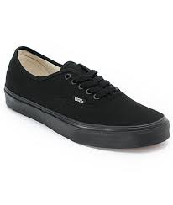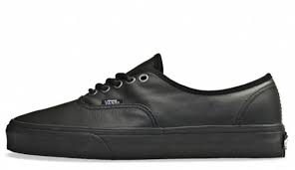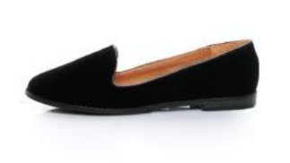

***Note: Students who play basketball or volleyball in the gym during Lyceum may wear the above approved black Vans during play activity. Students may also bring athletic shoes to change into during Lyceum.***